- Connect a USB webcam to your computer, install any required drivers, and verify that the webcam works by opening the default camera app and capturing a photo.
Answer
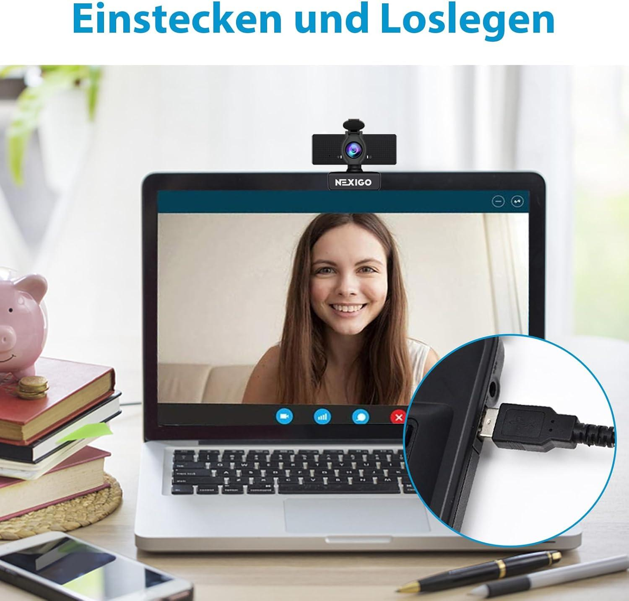
- Connect the webcam:
- Plug the webcam's USB cable into an available USB port.
- Place the webcam on top of your monitor.
- Wait a few seconds for Windows to detect the device.

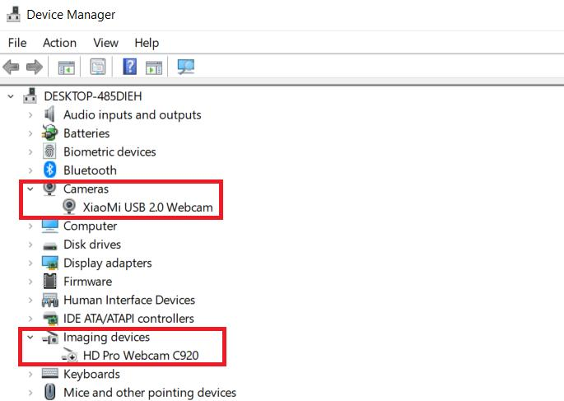
- Install the required driver:
- Right-click the Start button and open Device Manager.
- Expand Cameras or Imaging devices.
- If the webcam is listed with a warning symbol, update its driver through Windows Update or the manufacturer's official website.

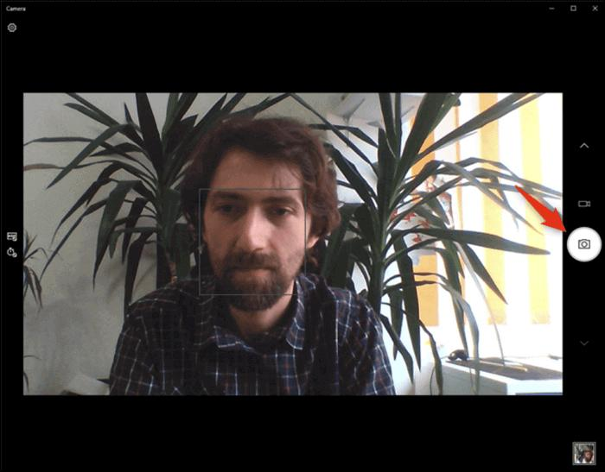
- Open the Camera app:

  - Press the Windows key.
  - Type Camera and open the Camera app.
  - Allow camera access if Windows requests permission.
  - If multiple cameras are available, switch cameras until your USB webcam appears.
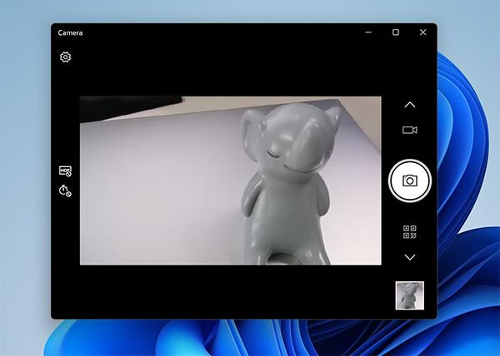
- Capture a test photo:
- Make sure the live preview displays your webcam image.
- Click the Take Photo button.
- Open the thumbnail to verify the captured photo.
- Check the Camera Roll folder inside your Pictures folder for the saved photo.

- Set up a local printer (USB or network), install the correct driver, and print a test page to confirm successful installation.
Answer
1. Connect the printer:
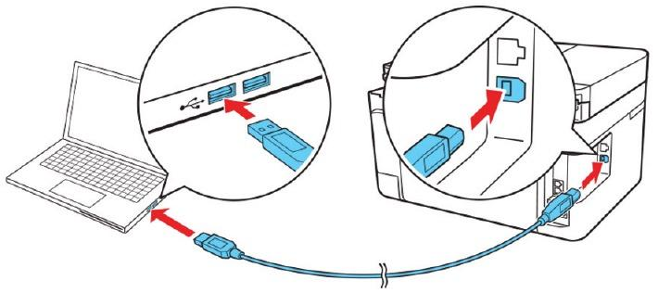
- Turn on the printer and check that it has paper.
- USB printer: Connect its USB cable to your computer.
- Network printer: Connect the printer and computer to the same local network.
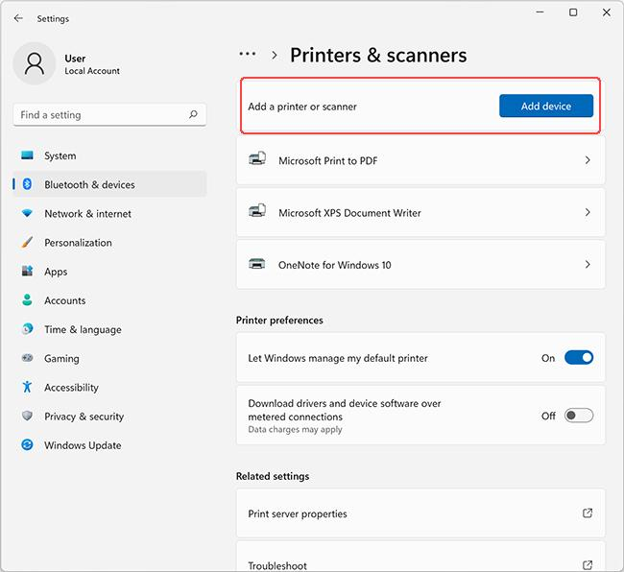
2. Add the printer:
- Open Settings.
- Select Bluetooth & devices → Printers & scanners.
- Click Add device.
- Select your printer and click Add device.

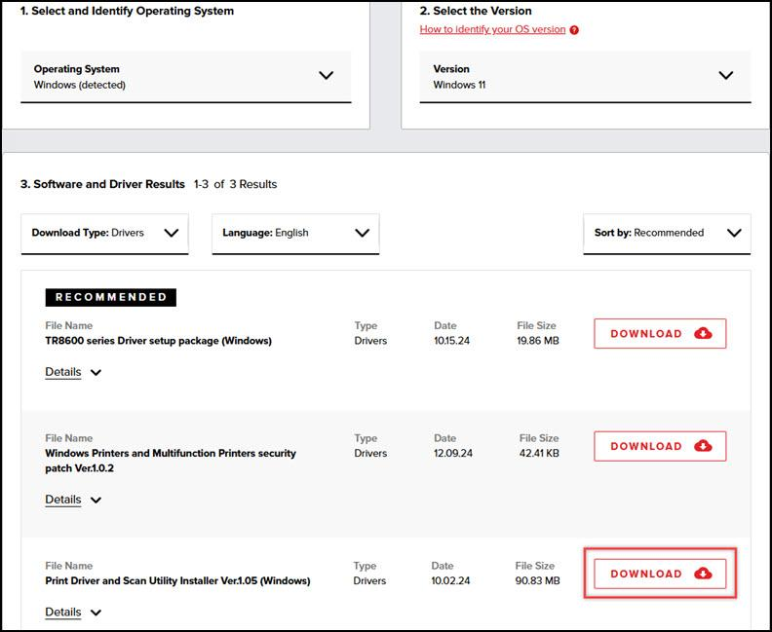
3. Install the correct driver:
- Allow Windows to install a compatible driver automatically.
- If the printer is not working, download the driver for the exact printer model and your Windows version from the manufacturer's official website.
- Restart the printer if necessary.

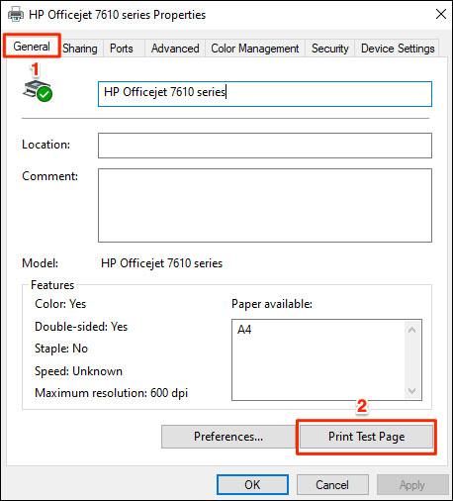
4. Print a test page:
- Open Settings → Bluetooth & devices → Printers & scanners.
- Select your printer.
- Open Printer properties (or the available printer management options).
- Click Print Test Page if available.
- Check that the page prints correctly.

- Simulate a connectivity issue by unplugging the printer's USB cable, then use Windows Device Manager to identify and resolve the 'printer not detected' problem. Hint: Check for error icons and use the 'Scan for hardware changes' option after reconnecting.
Answer

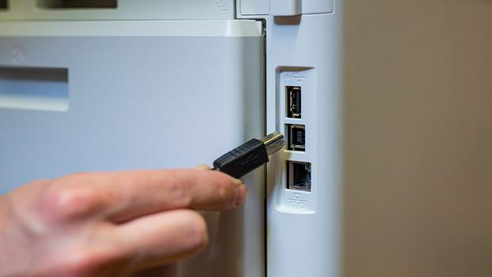
Step 1: Disconnect the printer:
- Keep the printer powered on.
- Unplug the printer's USB cable from the computer.
- Wait about 10 seconds. Windows may show the printer as offline or unavailable.

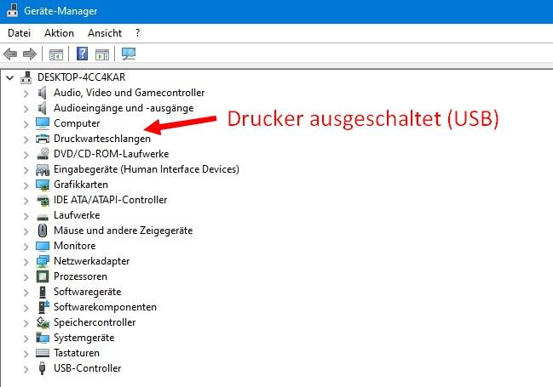
Step 2: Check Device Manager:
- Press Windows + X.
- Select Device Manager.
- Expand Printers, Print queues, and Universal Serial Bus controllers.
- Look for a missing printer entry, an unknown device, or a yellow warning icon.

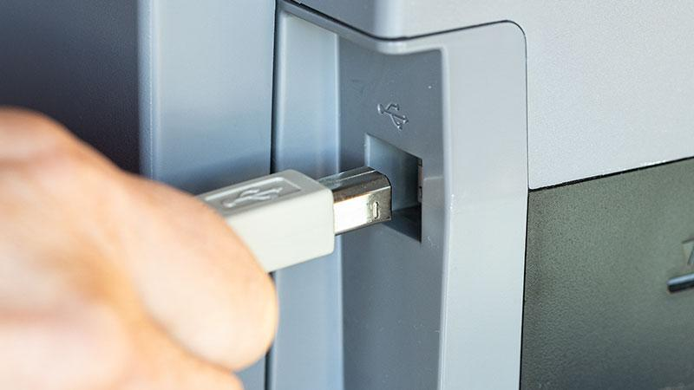
Step 3: Reconnect and scan for hardware changes:
- Reconnect the USB cable
- Plug the cable firmly into the computer and printer. If possible, try another USB port.

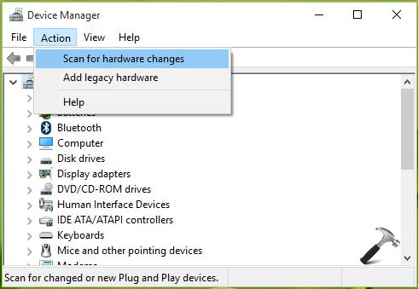
- Scan for hardware changes
- In Device Manager, select Action → Scan for hardware changes. Wait for Windows to detect the printer again.

Step 4: Resolve any driver errors:
- Right-click the affected device and select Update driver.
- If the printer appears as an unknown device, install the correct driver from the manufacturer's official website.
- If necessary, restart the computer and printer, then scan again.

Step 5: Verify the fix:
- Open Settings → Bluetooth & devices → Printers & scanners.
- Confirm that the printer appears, then open its properties or management options and print a test page.

- A user reports that their webcam video is not displaying in Zoom, but it works in the default camera app. Troubleshoot and resolve the issue so the webcam works in both applications. Hint: Check if another app is using the webcam or if Zoom permissions are enabled.
Answer

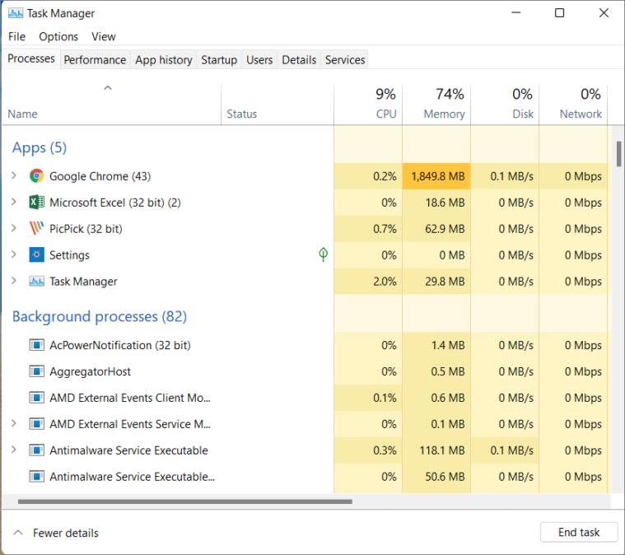
Step 1: Close other applications using the webcam:
- Close the Windows Camera app.
- Close other video applications, such as Microsoft Teams, Skype, and browser tabs using the webcam.
- If necessary, press Ctrl + Shift + Esc to open Task Manager and end any remaining camera applications.
- Reopen Zoom.

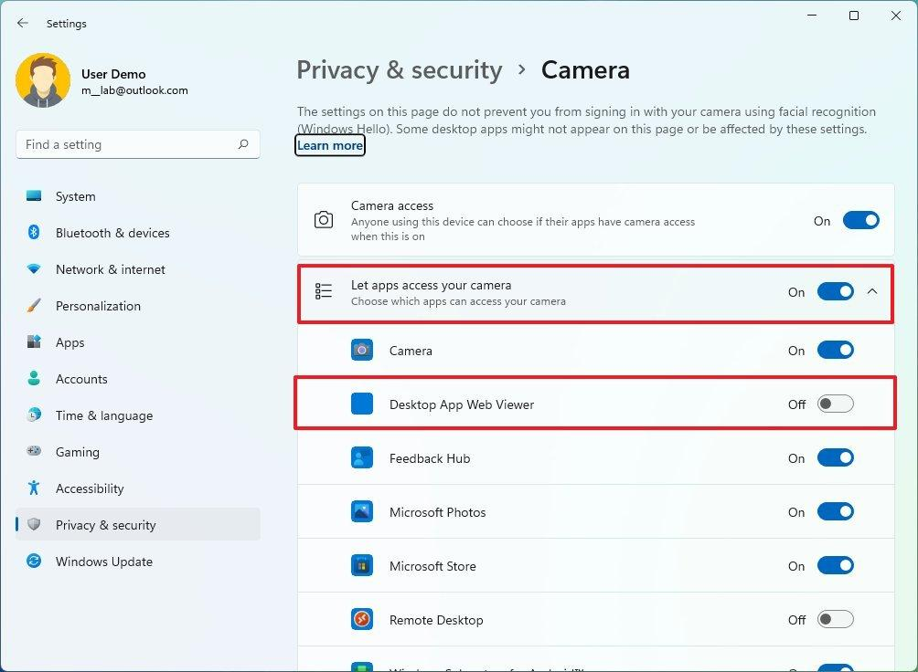
Step 2: Enable camera permissions in Windows:
- Open Settings by pressing Windows + I.
- Navigate to Privacy & security → Camera.
- Turn on Camera access.
- Turn on Let apps access your camera, if shown.
- Ensure Let desktop apps access your camera is enabled. Zoom's desktop application relies on this permission.

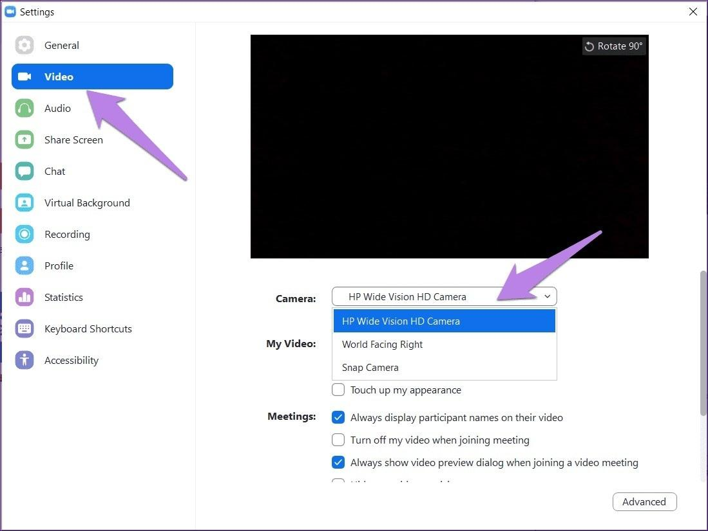
Step 3: Select the correct webcam in Zoom:
- Open Zoom.
- Click your profile picture and select Settings.
- Select Video or Video & effects.
- Under the camera selection menu, choose your USB webcam instead of another camera or virtual camera.
- Check whether the video preview displays your image.

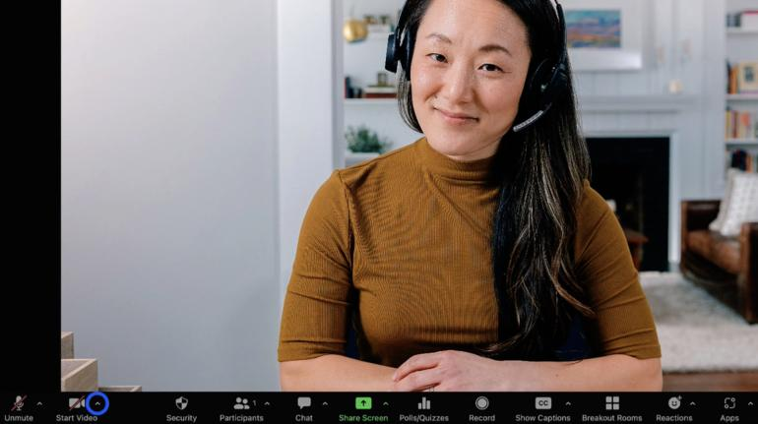
Step 4: Test the webcam in a Zoom meeting:
- Start a test meeting or join a meeting where testing is permitted.
- Click Start Video if the camera is off.
- Confirm that your video appears.
- If the screen remains black, restart Zoom and repeat the test.

Step 5: If the problem continues:
- Restart your computer.
- Update Zoom to the latest available version.
- In Zoom's video settings, try another available camera and then switch back to your USB webcam.
- If needed, check the webcam driver in Device Manager → Cameras.

